®

A Productivity & Optimal Living



Marianna Teudor
m.teudor@gmail.com
www.harmonyofficial.net

Tom Drews
tom@makingminutes.com
www.makingminutes.com

Table of Contents
Bucket Diagram 4
Bucket Goals Worksheet 5
Priorities 6
Procrastination 7
Time Wasters 8
What I’m Grateful For 9
What Makes Me Happy 10
Actions and Commitments 11
Mindful Minutes 12
Actions, Strategies, and Ideas for Making Minutes! 13
Resources 14
Suggested Actions 15
Bucket Diagram 16
Email Best Practices 17
Meditation Guide 18
Effective Meeting Best Practices 19
Time Management and Productivity Suggested Readings 20

Bucket Diagram

The Buckets

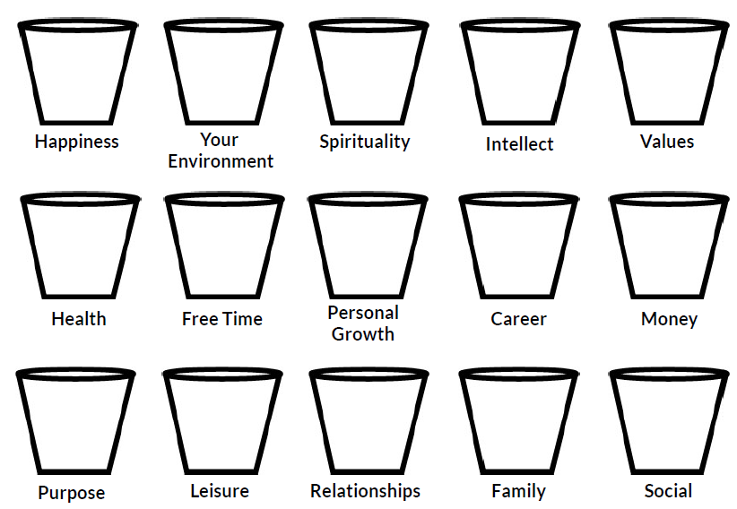

Bucket Goals Worksheet
BUCKET TWO
BUCKET ONE

YOUR GOAL: YOUR GOAL:

TIMEFRAME: TIMEFRAME:

PRIORITY ACTIONS: PRIORITY ACTIONS:

Priorities

Procrastination

What are you procrastinating on? | Why are you procrastinating? | Solutions

Time Wasters

What I am Grateful For

What Makes Me Happy

Actions and Commitments

Consider what you have learned today and list five action items and / or commitments that will have the greatest positive impact in your business and/or personal life. These can be from your buckets, list of time waters, or elsewhere.

Action and/or Commitment | Timeframe for Implementation | Support Needed, From Whom

Mindful Minutes

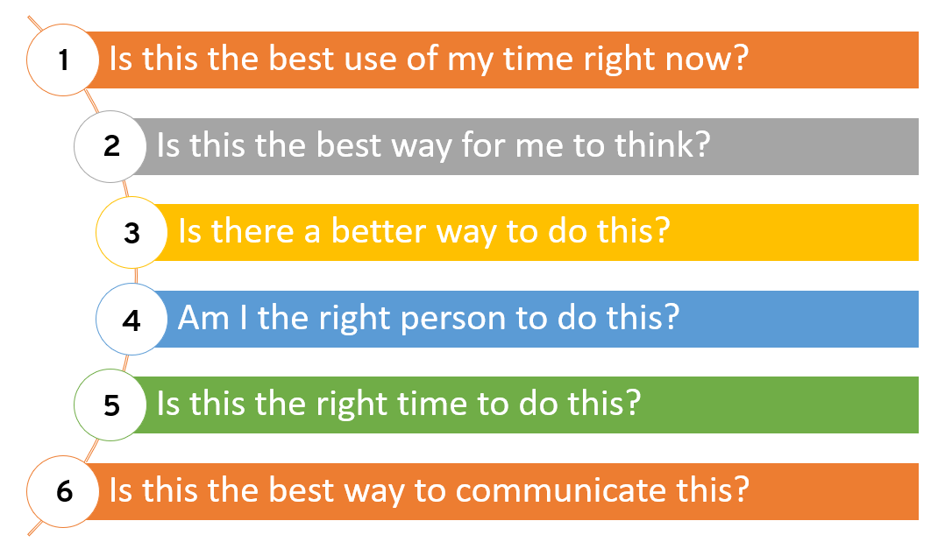

Actions, Strategies, and Ideas for Making Minutes!

Resources

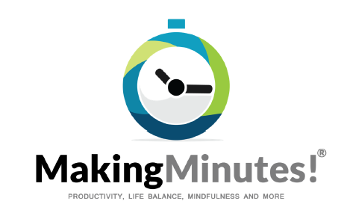

Suggested Actions

- Feel free to contact me if you have any questions: tom@makingminutes.com.
- Review the “5 Action Items” worksheet you filled out at the end of the workshop. Schedule time to follow through with each commitment. For instance, filling out your bucket goals sheet and listing out your top priorities.
- Browse through your completed workbook following the workshop to review your notes.
- Fill your buckets and set goals and action items (Buckets Worksheet).
- Access the Prioritizing / Dashboard spreadsheets and modify according to your needs. Follow the process outlined in the workshop for getting started. Review and update daily.
- Schedule important but not urgent activities on your calendar.
- Schedule at least one hour a week to implement Making Minutes.
- Review your email strategies for maximum efficiency and effectiveness.
- Access your company’s branded Meeting Agenda template when useful.
- Find an accountability partner and hold each other accountable.
- Challenge yourself to set your phone aside for two hours at a time.
- Practice the Mindful Minutes for one full day and make it a daily habit.

Bucket Diagram

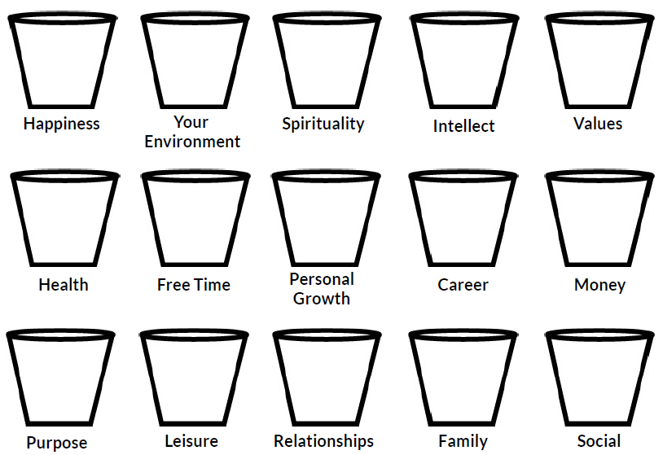

Email Best Practices

Cleaning Your Inbox to Near-Zero
- Schedule blocks of time to clear your inbox. Remember, it takes minutes to make minutes!
- Start by deleting junk and lower priorities. A great way to do this is to sort by “from” and then “subject” so you can delete chunks at a time.
- If it takes 2 minutes or less to respond, do it. Avoid reading more than once.
- Prioritize, categorize, and file the rest for later action. Using ABCD folders is useful. Begin diving in when you have time.
- Create a system that works for you. The goal is to have ongoing maintenance be as simple as possible.

Ongoing Maintenance to Maintain Near-Zero Inbox
- Do quick scans as needed throughout the day for urgent / important emails. Avoid actually reading the emails until you process them.
- Schedule blocks of time to process and respond to emails.
- Send fewer emails. Practice Mindful Minutes – is this the best way to communicate this?
- Turn off notifications that interrupt or distract you regularly.
- Prioritize and categorize for later action. Use ABCD folders.
- Short and to the point. Use bullet points if appropriate.
- Delete the string. You only need to keep the most recent email. The rest can be deleted. Remember, if you change the topic in the email, you will also need to change the subject line.
- Create templates for emails that have the same content and are sent frequently.
- Unsubscribe or block unwanted emails. Blocked emails go straight to “junk.”
- Create rules for emails you receive regularly and may want to reference at some point but aren’t important enough to look at immediately. Newsletters are a great example.

Remember, it takes minutes to make minutes!

Meditation Guide

Meditation is a powerful practice that is good for both your brain and body. Studies show that even ten minutes a day can have a significant positive impact on your health, happiness, and well-being. (Source: FitBrains)

Pick a general time | Meditating is a great way to start off your day. But if you are too rushed in the morning, any time that’s convenient is fine. Just try to pick a time that you can do daily so it becomes easier to make it a habit.
Find a quiet spot | It can be your desk, a couch, in your bed, on a park bench, or even while waiting in line.
Get into a comfortable position | Either sit or lie down, no slouching! The Savasan (aka “dead corpse”) pose in yoga is a great one – lie down with your palms facing up.
Keep your eyes open and soft | Focus your eyes on one spot and soften your eyes. If you have trouble concentrating, try shutting your eyes.
Focus on your breathing | Clear your mind. Follow the natural flow of your breath from your nose to your lungs. Notice how your chest, rib cage, and belly ebb and flow with each breath. If you start getting distracted, gently re-focus back on your breath. If you still can’t focus, count to five while focusing on your breath.
Do this for 5-10 minutes daily | Once you master meditating for a few minutes, increase the number of minutes the next week.

Effective Meeting Best Practices

Leader Responsibilities
- The leader is 100% responsible for the entire success of the meeting.
- The leader should have a clear reason for the meeting, otherwise, don’t do it.
- Invite only the necessary people for the meeting and assign roles.
- Always have an agenda with timeframes, ideally send in advance.
- Have a clear objective and state it during your meeting.
- Set specific action items for appropriate people with timeframes.
- Use a “parking lot” to keep meeting from going off track.
- Designate someone to take notes and log action items.
- Have a timekeeper to make sure presenters stay on time.
- Start on time.
- Schedule shorter meetings if possible (30-50 minutes instead of an hour).
- Come prepared with handouts and any other necessary materials.
- Send meeting notes and any other relevant documents following the meeting.

Participant Responsibilities
- It’s okay to decline a meeting if you have a legitimate reason.
- Ask for a meeting agenda if one isn’t provided.
- Ask for the meeting objective if one isn’t provided.
- It’s okay to say “I have a hard stop at such and such a time.”
- Respond yes or no to the meeting request.
- Show up on time – early, if possible.
- Request meeting notes as a follow-up.
- Is it okay to leave the meeting early if your role is complete?
- Is it okay to work on your laptop during the meeting?

Time Management and Productivity Suggested Readings

The Happiness Advantage | Shawn Achor
The 7 Habits of Highly Successful People | Stephen Covey
The NOW Habit | Neil Fiore
The Portable Coach | Thomas J. Leonard
Time Management for Dummies | Jeffrey Mayer
University of Success | Og Mandino
The Art of Living | Epictetus
Eat That Frog! | Brian Tracy
The 10 Natural Laws of Successful Time and Life Management | Hyrum W. Smith
Feel the Fear and Do It Anyway | Susan Jeffers, Ph.D.
Ready for Anything | David Allen
Getting Things Done | David Allen

